**Just In Time and Lean Manufacturing**

**Introduction**

***Just In Time:*** Speed to Market and the production costs can boost the company or can break the company. JIT is a workflow methodology aimed at the reducing flow times within the production systems as well as response times from suppliers and to customers. It helps the organizations control their variability, helps to improve productivity while lowering the costs.

***Lean Manufacturing:***  Lean Manufacturing is the application of principles, practices, and tools to the development and manufacture of physical products. Many manufacturers are using Lean Manufacturing principles to eliminate waste, optimize processes, cost cutting, innovation boosting and reduce time to market in a fast-paced, volatile, ever changing global marketplace.

**Lean Manufacturing Concepts**

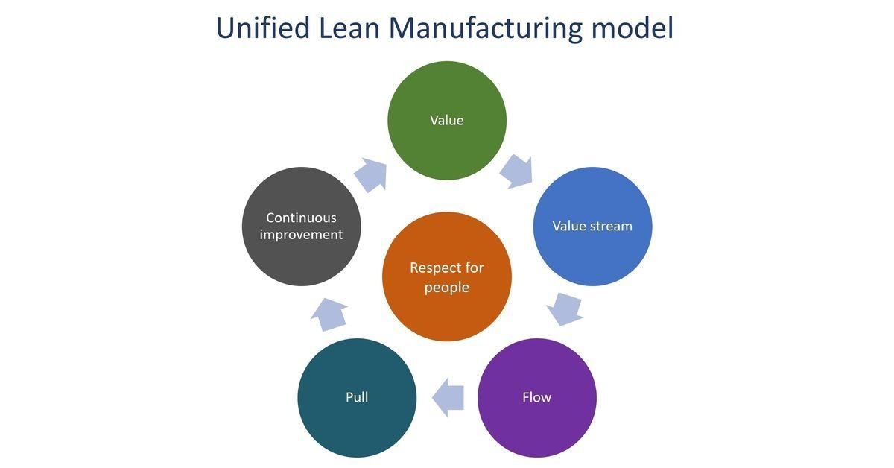

***Value Stream Mapping***

Value Stream is a process to turn a customer request into a deliverable piece of value. Value stream mapping is the analysis of that process and can be used to improve any process where there are repeatable steps, and especially when there are multiple handoffs. The purpose of value stream mapping is to be able to analyze the overall process and each of its steps, to be able to design out (to borrow from TPS) overburden, inconsistency, and waste.

***Continuous improvement***

Continuous improvement is essential for sustainable success for an organization-wide commitment with Lean manufacturing. Lean is continuous improvement – it’s improving product and process while eliminating redundant, excessive, or inefficient activities. Continuous improvement can be viewed as a formal practice or an informal set of guidelines – but it must be well integrated into the culture of an organization in order to make a meaningful and lasting difference.

***Measurement, KPIs, and visualization***

Lean manufacturing metrics, such as lead time, cycle time, throughput, and cumulative flow help organizations measure the impact of their improvement efforts. Collecting, analyzing, visualizing, and socializing these metrics (through shared dashboards) is essential to promoting transparency and driving change.

Successful Lean manufacturers use up-to-date dashboards at the team, leader, and executive levels to paint an accurate picture of the impact that changed processes are having. It should be noted that the emphasis is on surfacing key performance indicators of processes – not people. This reinforces a collective responsibility by teams to pursue opportunities for improvement and focus on value creation for customers.

***Demand-based flow (pull) manufacturing***

Lean manufacturing is all about optimizing flow: Creating a system that sustainably, consistently delivers value. The sustainability part of this relies on effectively managing capacity – making sure that the workload is balanced and manageable throughout the value stream. Implementing a demand-based, or (pull) manufacturing system is key to effectively managing capacity.

In a pull manufacturing system, inventory is only pulled through each production center when it is needed to meet a customer’s order. Pull systems allow “just-in-time” delivery of work. Unlike other work methods that allow for an unlimited amount of work at once, a pull system enables everyone at a specific organizational level to focus on one thing (or just a few things) at one time.

Benefits of using a Kanban control system or pull system include:

1. Ability to manage change
2. Ability to quickly adapt work to new information
3. Increased ability to scale the team to the appropriate size for the project

**Concepts of JIT**

***Eliminating waste:***

Reducing the waste is one of the main objectives of JIT system.

There are seven types of waste:

1. waste from overproduction.
2. waste of waiting time.
3. transportation waste.
4. processing waste.
5. inventory waste.
6. waste of motion.
7. waste from product defects.

***Good housekeeping***: Cleanliness is very important for any workplace and organization. Cleanliness boosts the interest of people who work which will lead to increase in the productivity.

***Set-up time:*** An effective Just In Time System (JIT System) environment generally requires reduced setup time. Reduced setup time offers the capability to react swiftly to customer orders and shrinks the demand for safety stocks. So, it is considered under the Key Elements of JIT Systems***.***

***Flexible workforce:*** Workers should be multi-skilled in a Just In Time System environment, which is often organized into small “cells” that contain all of the equipment required to carry out many steps in the production process. Workers should be capable of handling all of the various equipments in the work cell. Also, workers are typically expected to perform maintenance tasks on their own equipment and to do their own quality inspections. So, Flexible workforce is considered under the Key Elements of Just In Time System.

***Plant Layout:*** JIT provides enhanced plant layout. The layout of the manufacturing plant should be improved to decrease distances work-in-process should flow. In conventional layouts, all of the machinery of a comparable class are assembled together in one cost center or physical location. For example, all of the granulation machines are ordinarily in one location and all of the compression machines in another. As a result, work-in-process must move lengthy distances between operations. There are a number of evils with this. At first, relocation of components around the plant results in unnecessary costs incurrence. Secondly, relocation leads waiting time. Thirdly, it is challenging to keep track of singular items when the inventory is scattered all over the production floor.

***Defect Rates:*** JIT technology ordinarily offers lower defect rates. An establishment must persistently endeavor for reducing the defects. Big numbers of defects entail that excess work-in-process be put into operations to ensure that there will be adequate defect less output to satisfy customer orders. Hence, defects must be taken care and possibly eliminated in a JIT environment. So, Defect Rates is also considered the key elements of Just In Time System or JIT System.

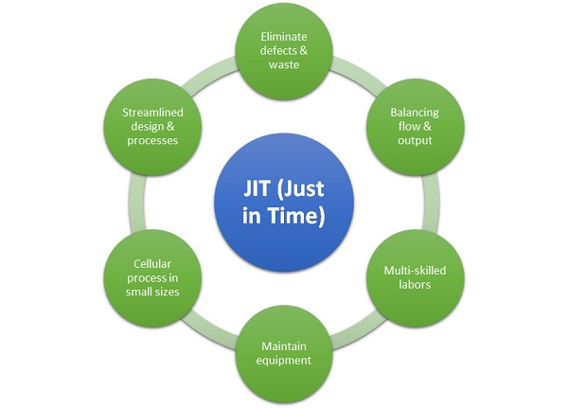

**Conclusion:**

By properly implementing the above concepts, system helps MG Motors to strengthen their competitiveness on the market. Just-in-time helps companies to:

1. Reduce waste and eliminate activities that don’t bring value.
2. Improve the quality of their products and processes.
3. Increase levels of productivity and optimize expense.